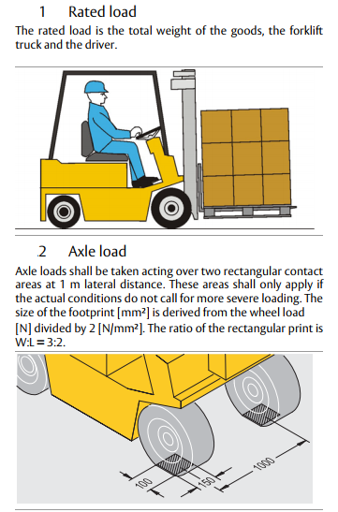
FOR 9 TON CAPACITY DOCK LEVELER -
Total load is distributed through 4 each tyre of forklift hence each wheel carries equal load 9000/4 = 2250kg.
So, 9 MT dock leveler can take 2250 kg of load in 150x100mm concentrated area (contact area of type of Forklift).

